DBOOK

WASHINGTON STATE DEMOCRATS

'J)wf5A.l 'Yelz, Cltair

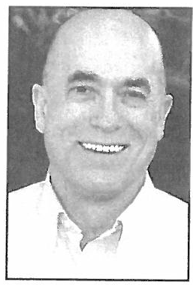
Dear Precinct Committee Officer,

As a PCO you are the foundation of the Democratic Party, the organizing base of all our activities. The structure of the Party rests upon your shoulders .

By stepping forward to organize your precinct , you have made the most important
commitment a Democrat can make. You have taken responsibility for delivering each and every Democratic vote in your precinct on Election Day. It is an important responsibility and I thank you for undertaking it.

This Handbook was written to assist you in your role as a PCO . It will answer many of your questions about the structure of the Party organization, the duties and respons ibilities of being a PCO, and the best way to utilize available resources in order to effectively mobilize your precinct. Taking the time to read this Handbook and using it as a reference during your time as a PCO will help elect Democrats at the local , state, and national level.

Getting the crucial Democratic vote in your precinct begins long before Election Day. It requires planning and preparation. You have to get to know your neighbors and determine whether they are Democrats, Republicans, or Independents .You also need to educate the undecided or "swing" voters about the Democratic candidates and the Democratic message and register any Democrats in your precinct who are not currently registered . Your neighbo rs will also turn to you for informatio n and insight on political Issues.

Another important aspect of serving as a PCO is being an active participant in your local Democratic Party organization. Local party organizations are a great resource for materials and ideas that will make you a more effective PCO. They also serve to coordinate Democratic efforts in legislative districts and counties across the state. As a PCO you are eligible to stand for election as a Party officer in these organizations.
Just as your local Party organization is there for you, you need to be there for it. It is your responsibility to
attend local Democratic Party meetings and help your Party and Democratic Candidates raise money and find volunteers.

This Handbook will help you fulfill your responsibilitie s as a PCO and assist you in becoming an active and effective member of your local party organization . Your efforts will increase the Democratic vote and help Democratic candidates statewide.

Your hard work and commitment are greatly appreciated. Sincerely,

Dwig t Pelz, C

Table of Contents

Structure of the Democratic Party

Overview 1
Precincts and PCOs 1
Legislative District and County Organizations 2
Washington State Democratic Central Committee 2
Democratic National Committee 3
The Caucus and Convention Cycle 4
Being a Precinct Committee Officer
Your Responsibilities 5
Basic Responsibilities 5
Additional Responsibilities 5
Using Walking Lists 6
What To Do At the Door 6
At the Door- Important Tips 7
What Decides a Likely Party 7
More Tips 8
Make Sure to Follow Up 8
Canvass by Phone 8
Locked Buildings 9
Beyond the Precinct
Get Out the Vote (GOTV) 10
GOTV and Your Precinct 10
GOTV Phone Calls 10
Table of Contents
The State Party and You: The Years of the Grassroots
Affiliated Groups 11
Young Democrats 11
Technology
The Online Voterfile 12
What is VoteBuilder? 12
How to Use VoteBuilder 12
Creating Your Lists 13
How to Enter Data 13
Online Resources 14
The Washington State Democrats Web Sire 14
The Washington State Democrats Online Community 14
Social Networking Sires 15
Sa111ple Walking List 16
County Auditors & Elections Departments 18
Appendix
Congressional District Map 19
Legislative District Map 21

Structure of the Democratic Party

Overview

PRECINCT

" I# 't (
LEGISLATIVE COUNTY
DISTRICT ORGANIZATION ORGAN IZATION

'( (
WSDCC
I J

DNC
$ •
a

There are more than 6.6 million people in Washington, and roughly 3.6 million of these individuals are registered voters. The Democratic Party identifies each of these individuals by the precinct, legislative district and county in which they live. The Democratic organizations at each of these levels make up the structure of the Democratic Party.

Precincts and PCOs

The base unit of organization for the Democratic Party is the precinct. A precinct may contain several blocks in an urban area or consist of a group of houses near one another in a more rural setting. There are roughly 7,500 precincts in the State ofWashington.

The average number of registered voters in a precinct in Washington is around 550, but most precincts range from 300 to 800 voters. There are 55 to 220 precincts and 49,000 to 86,000 registered voters in a legislative district.

The responsible Party official at the precinct level is the Precinct Committee Officer (PCO). There are three types of PCOs: Elected PCOs, Appointed PCOs and Acting/Service PCOs.

- Elected PCOs are voted into office during the primary election in even-numbered election years to serve two-year terms. The State Party requires that all elected PCOs receive at least 1Oo/o of the vote total of the highest vote total for a Democrat in that precinct.

- If no PCO is elected in a particular precinct, then a democrat who lives in that precinct can be appointed as the PCO. For more information about the requirements for becoming an Appointed PCO, contact the Chair of your legislative district or county organization.

- If an activist is interested in serving as a PCO, but lives in a precinct that already has a PCO, they can be
appointed to serve as an Acting PCO in a different precinct.

Legislative District and County Organizations

There are 49legislative districts and 39 counties in Washington. Each is represented by a Democratic Parry
organization, which has the following characteristics:

  - MEMBERS. Each legislative district and county organization is composed of elected and appointed PCOs in addition to other active democrats and members of the community.

  - ELECTION OF OFFICERS. Reorganization meetings, which occur in December or January after the general election in even-numbered years, are where PCOs elect their local party leadership. Only precinct committee officers elected during the primary election in an even number year are allowed to vote at legislative district and county reorganization meetings for Chair, Vice Chair, State Committeewoman, State Committeeman, and any representative the organization is authorized to send to other party organizations, and on the adoption or amendment of bylaws . Both elected and appointed PCOs are eligible to vote to fill vacancies that occur in party offices before the next reorganization meeting . The election of other officers is dictated by the local party organization's charter and bylaws.

  - MEETINGS. Most legislative district organizations hold monthly meetings. Most county organizations hold quarterly meetings, although the executive board often meets monthly. These meetings are scheduled for the purpose of sharing information about party matters, current events and candidates. Official "calls" to these meetings are dictated by the bylaws of the organization but are often posted on the local party's website, emailed to members or contained in a monthly newsletter published by the party organization.

- RESPONSIBILITIES . Legislative district and county organizations are responsible for supporting and recruiting PCOs and recruiting and training volunteers for campaigns. They also raise funds to help finance these campaigns. One of the most important functions of the party organization is to fill vacancies on the party ticket (see "The Role of the PCO in Filling Legislative Vacancies" on page 3).

Washington State Democratic Central Committee

The Washington State Democratic Central Committee (WSDCC) is the state-wide Democratic Party organization. The WSDCC consists of one male and one female State Committee Member from each legislative district and county organization. The WSDCC is presided over by a Chair and other officers who are elected by the State Committee Members at the reorganization meeting, held in odd-numbered years during the last weekend of January.

The WSDCC sets the tone for the Democratic Party in the State ofWashington. It assists legislative district and county organizations in supporting, recruiting, training, and financing campaigns for state, legislative district and county office. It also takes the lead in recruiting and assisting Democratic candidates for federal and statewide office.

The offices of the WSDCC are located at 615 2nd Ave., Suite 580 in Seattle, WA 98104. The mailing address is PO Box 4027, Seattle, WA 98194. For more information, go to www.wa-democrats.org or call (206) 583-0664.

Democratic National Committee

The Democratic National Committee (DNC) is the national Democratic Party organization. The DNC is composed of members elected from each state. Two men and two women from Washington are elected to serve four-year terms as DNC members by the WSDCC at the January meeting in Presidential election years. The State Party Chair and Vice Chair are also members of the DNC. The DNC is presided over by a Chair and other officers elected by its members.

The DNC takes the lead in setting the Democratic agenda for the nation. They support the President when he or she is a Democrat and lead the opposition when Republicans control the White House.

They are located at 430 S. Capitol St. SE, Washington, DC 20003. For more information, go to
www.democrats.org or call (202) 863-8000.

The Role of the PCO in Filling Legislative Vacancies

Each PCO is a member of the legislative district and county organization and is empowered by the State Constitution to do the following...

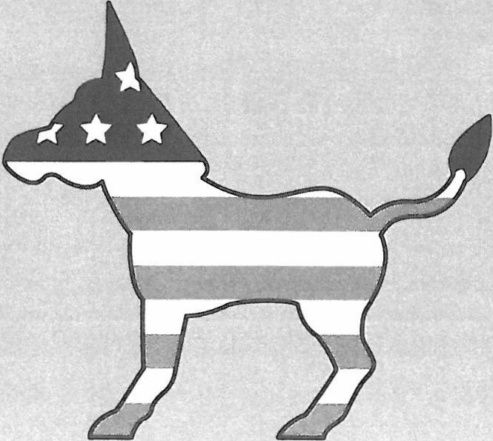
tl' The county organization nominates people for appointment to partisan county offices and legislative offices in districts entirely within the county if an incumbent of the Party leaves office.

tl' For legislative districts containing parts of two or more counties,
the PCOs from that district can nominate people for appointment to legislative offices if any incumbent of the Party leaves office.

Caucus and Convention Cycle

PRECINCT CAUCUS
•' w
LEGISLATIVE DISTRICT CAUCUS
STATE CONVENTION

T
COUNTY
CONVENTION

CONGRESSIONAL
  - DISTRICT CA·UCUS

' NATIONAL CONVENTION
-,.

Caucuses and conventions are held in even-numbered years. The diagram shows the structure of the caucus and convention cycle. Congressional District Caucuses and the National Convention are held only in presidential election years. During presidential election years, delegates are selected based on their presidential candidate preference.

What Happens at Caucuses and Conventions:
- PRECINCT CAUCUS. Precinct caucuses are held in presidential years only. Local party organizations hold precinct caucuses, where attendees select delegates. They must be held in wheelchair-accessible locations. Therefore, most precinct caucuses are held in appointed locations, rather than in private homes.
- COUNTY CONVENTION. County conventions are where Democrats discuss local issues and candidates, adopt a county platform and pass resolutions, which are submitted to the Platform Committee of the state convention. In presidential years, delegates to the County Convention are elected at the Precinct Caucuses; in non-presidential years all Democrats are invited to participate.
- LEGISLATIVE DISTRICT CAUCUS. Legislative District Caucuses elect delegates to the state convention, adopt a legislative district platform and pass resolutions, which are submitted to the platform committee of the state convention. In presidential election years, the delegates they elect are also delegates to the congressional district caucuses. In presidential years, delegates to the legislative district caucus are elected at the precinct caucuses; in
non-presidential years all Democrats are invited to participate.
- CONGRESSIONAL DISTRICT CAUCUS. Congressional district caucuses are held in president ial
election years only. Delegates from the legislative district caucuses elect delegates to the national convention. Each congressional district will elect three to seven delegates to the national convention based on prior democratic performance in that district.
- STATE CONVENTION. Delegates from the legislative district caucuses discuss and vote on a State Party platform, vote on resolutions submitted from county conventions and legislative district caucuses, and make decisions regarding Party governance. In president ial election years, they elect additional delegates to the national convention.
- NATIONAL CONVENTION. In presidential election years, the DNC holds a convention to adopt a platform and nominate a Presidential and Vice-Presidential candidate. It also conducts other Party business, such as adopting resolutions .

Being a Precinct Committee Officer

Your Responsibilities

As a PCO, you are the foundation of the Democratic Party. The structure of the Party rests on your shoulders. It is important that you take the job of being a PCO seriously.

PCOs do their job best if they are the peers and neighbors of the people they represent. If you move from the precinct in which you are a PCO, contact the Chair of your legislative district or county organization and submit a letter of resignation so that a resident of the precinct can be appointed to serve as the new PCO for that precinct.

Basic Responsibilities

PCOs have the following basic responsibilities:

  - Canvass or telephone your precinct in coordination with election strategy at least once a year.

  - Coordinate with campaigns in educating voters and generating interest in the election on behalf of
candidates and ballot measures.

  - Attend the legislative district and county organization meetings. Each legislative district and county organization specifies the duties and responsibilities they expect of you.

Additional Responsibilities

The following additional duties and responsibilities are commonly assigned to PCOs:

  - Obtain a list of registered voters in your precinct from your legislative district or county organization, called a walking list. Speak to your Chair about obtaining an online Voterfile account (see "The Online Voterfile" on page 12).

  - Deliver campaign materials to voters.

- Make sure Democratic voters are registered and that infrequent voters vote.

- Canvass your precinct during elections to make sure that Democratic voters in your precinct have voted.

- Maintain , update and provide a copy of the contact and registration information for registered voters in your precinct . Useful information includes telephone numbers , e-mail addresses, age, ethnicity and issues important to the voter.

- Keep informed on current issues and candidates.

- Have a working knowledge and understanding of the Party platform. The State Party platform is available at www.wa-democrats.org.

- Chair your precinct caucus (see "The Caucus and Convention Cycle" on page 4).

- Help fill vacancies (see "The Role of the PCO in Filling Legislative Vacancies" on page 3).

Using Walking Lists

You should have a firm grasp of all that is included in your walking list. A sample walking list can be found on page
- Your walking list contains valuable and interesting information. The header has your county, your precinct
name, precinct number and what is on that page of the walk list (street name, and odd or even if applicable).

The names and addresses of the registered voters in your precinct are listed. They are usually grouped by street and listed by household in order to make it easier for you to walk your precinct. The following fields are available for each voter:

  - Reg Date: The date the voter registered .

  - Phone:The voter's telephone number.

  - Party:The likely party for the voter (see "Likely Party" section next page)

  - Age: The age of the voter.

  - Sex: Sex or gender of the voter.

  - VH-G, VH-P: Indicates how many recent elections the individual has voted in. "G" stands for even-year general elections, and "P" stands for even-year primary elections. These columns will h.elp you identify infrequent voters. You can make a big difference in an election if you get infrequent voters to vote.

  - Script Answers: Where you can note answers each voter gives you to the questions you ask at the door.-

REMEMBER

If there is a field that is blank on your walking list, make an effort to find the missing information. Take note if voters have moved into or out of your precinct or if voters have passed away. Report the updated information to your legislative district and county organization and in vote builder so that they can keep track of the changes. This
information is crucial to Democratic success on election day. As a PCO, you can best ensure that the data is accurate
and up to date!

What To Do at the Door

Hopefully you've planned your first walk of your precinct well in advance of election day. The job of a PCO is far too important to leave to the last minute. Give yourself plenty of time to get to know your precin ct and the voters living there. It's also important that the voters get to know you . A good step in this process is to establish yourself as a neighbor. This helps put people at ease and opens the door to further conversation. Start with something like, "Hi, I'm Ben Fitch, and I live on 11th Ave. I'm the Democratic Precinct Committee Officer elected/appointed to represent our precinct. Is Jennifer Blackwood here?" (Be sure to ask for the voter by name.)

Gather information by asking the voter basic questions. This will help break the ice and get the conversation
- lowing. These questions should be based upon the information you already have about them on your walking list or
from previous conversations. Keep the conversation light and avoid arguments.

Below are a few examples of opening questions for different types of voters:

  - Unknown and No Data voters. "''m talking with neighbors in out precinct to find out a little more about their politics . Do you consider yourself a Democrat, Republican, or Independent? "

    - Independent voters. If the person seems uninterested or unwilling to label themselves politically, try to engage them in a conversation about issues. You can begin by asking, "What issues generally motivate you to support or oppose a candidate for office?"

- Leaning voters (LD or LR). Ask them the same basic questions you would ask unknown voters to learn
more about their preferences.

- Democrats (SD or LD). Talk to them more about the Democratic Party to get an idea if they would be interested in any of the following:

V' Joining the local party organization

V' Putting a sign in their yard for a Democratic candidate

V' Making a contribution to the Party or a Democratic candidate

- Republicans (SR). Confirm that they are Republicans before writing off these voters and not going
to their doors.

At the Door - Important Tips
- Leave materials at someone's door if they are not home. Never leave materials in the mailbox. Doing this is against the law.

- Avoid doorbelling during the dinner hour, before 1Oam, after 9pm and after dark.

- Some PCOs like to campaign. This is fine, but some prefer to let the literature do the campaigning.

- Be courteous, flexible and brie£

- If someone asks you a question, don't be afraid to say that you don't know the answer. Try to find the answer
for them and make sure to follow up on this commitment.

WHAT DECIDES A LIKELY PARTY

On your walking list "Likely Party" is a designation of how we think a voter will vote

SD - Strong Democrat. An individual who has been identified as a Democrat in multiple races.

LD - Likely Democrat. An individual who has been identified as a Democrat but not as often as an SD or not 1OOo/o of the time as a Democrat.

ID, I, IR - Independent Democrat, Independent, Independent Republican. An individual who has been identified as an independent or as a Democrat in some races and Republican in others.

LR - Likely Republican. An individual who mirrors the LD except as a Republican.

SR - Strong Republican. An individual who has been identified as a Republican in multiple races.

U - Unknown. An individual who has been canvassed but not often enough to determine a likely party.

ND - No Data. An individual who we have not identified the likely party of at all.

7 Washington State Democratic Party Precinct Committee Officer Handbook

More Tips

This section contains tips that you should remember when you approach your neighbors for the first time and as you develop your relationship with them.

Make Sure to Follow Up

The key to success is letting the voter know that you are there for them. Plan to follow up with them in the future. There are several ways you can do this successfully:

- Follow up with your County Auditor or your Voterfile coordinator to check on changes in voting status.

- Call undecided voters to see if they have any questions.

- Deliver additional information to Independent voters or likely Democrat voters.

- Call known Democratic voters to remind them to vote.

- Call known Democrats and anyone else who may be interested to let them know about special political
events in the area.

Canvass by Phone
If you live in a rural area or a precinct with many inaccessible apartment buildings, telephoning voters may be the best way to accomplish your canvassing goals.

To find the phone numbers of the voters in your precinct, you can use the online Voterfile (see "The Online Voterfile" on page 12). After you log on to your account, look at the Phone List to find voters' phone numbers. Search voters without phon e numbers to see which voters we don't have numbers for. If you find these voters' phone numbers, enter them into the Voterfile. By entering phone numbers into the Voterfile, you are providing campaigns and other institutions with incredibly useful information.

The Internet

It is vital that PCOs are on the Internet and have an email address. It is something important that you can do to help your party. Not only will it save the party time and money, but it will also make you a more efficien t and effective PCO. Information about your county auditor or elections office, elected officials, candidates, your local, state or national party organization, and current political issues can easily be found using an online search engine like Google.

Approach the voter like you would if you were going door to door.The following is the generic party canvas script you can use when canvassing:

"Hello, I'm , your Democratic Precinct Committee Officer. I'm calling people in our neighborhood to find out a little about their interest in politics.I'm wondering, do you generally consider yourself a Democrat or a Republican?"

If they answer "Democrat"- "We're conducting a registration drive and would like to inquire if you are a registered
voter. Is there anyone currently in your family or household that needs to be registered to vote?"

If they answer "Republican" - "Thank you for your time, and have a good day."

Carefully note all information that you receive and politely thank the voter at the end of the conversation. If the voter becomes irritable, politely thank the person, end the call and note their response so that the voter is not approached again .

Locked Buildings
Locked apartment buildings make it difficult to canvass. Try to find a friend inside to let you in or escort you around the building. Usually at least one voter or manager will let you in if you contact them over the intercom. One approach is to say, 'Tm , your Democratic Precinct Committee Officer, and I have some literature for your registered voters."

If all else fails, leave your literature by the mailboxes or the entrances. Do not leave them in the mailboxes. Sometimes you will get a good response if you leave a note with each packet, giving your name and contact information. If you cannot canvass these buildings, consider doing a telephone canvass of registered voters in the building.

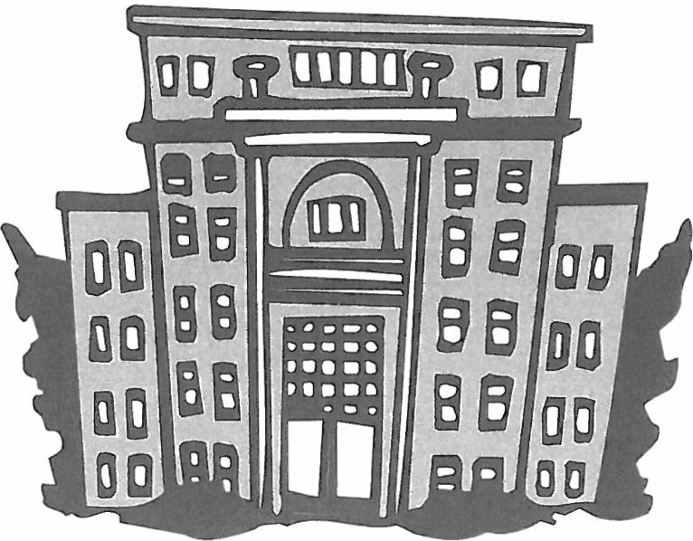

Beyond the Precinct

Get Out the Vote (G01V)

Most GOTV efforts are coordinated with political campaigns or legislative district and county party organizations. The Washington State Democrats have a very effective and comprehensive GOTV effort during the election season that is run by the Coordinated Campaign.

GOTV and Your Precinct
Your involvement in the GOTV effort is crucial to electing Democrats at the local, state and national level. One way to help is to ask voters in your precinct, during your early canvassing activities, if they would be interested in assisting with GOTV efforts during the election season. Developing a group of committed volunteers and activists in your precinct will prove invaluable to the GOTV effort.

GOTV Phone Calls

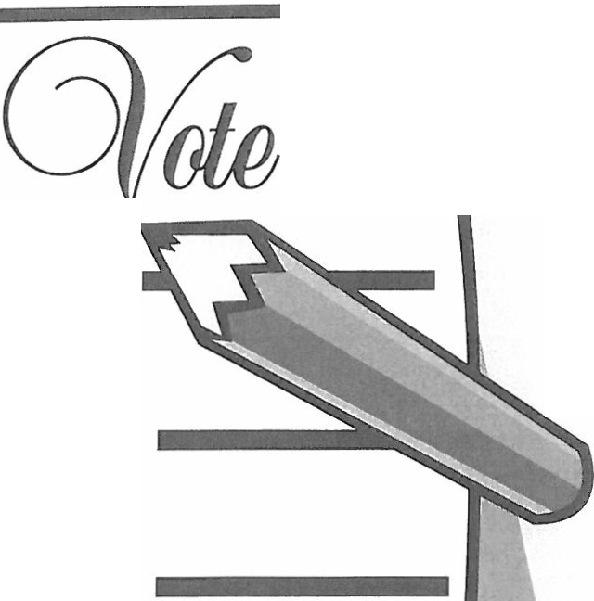
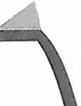
As Election Day approaches, it is important to contact Democratic

voters in your precinct and make sure that they vote. One way to do this is by phone.
The following is a sample script for GOTV phone calls:

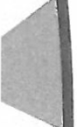
"Hello, I'm , your Democratic Precinct Committee Officer (or precinct worker). Your vote is very important, and I'm calling to remind you to vote/mail in your ballot ."
0

If the person has already voted - "Thank you for voting,
and have a nice day!"
0

If rhe person hasn't voted- "Your vote is very important. We have elections in our area that may be determined by just a few votes. Please mail in your ballot today."
0

Be prepared for any questions the person may have. Make sure you know the contact information for your auditor and where people can mail in their ballots
(see "County Auditors and Elections Departments"
on page 18). Remind voters that their ballots must
be postmarked by midnight of Election Day.

The State Party and You

Affiliated Groups

There are many groups affiliated with the State Parry who can help you and provide you with resources. Remember: you are not alone!

Young Democrats

The mission of the Young Democrats ofWashington State is to draw people who are 35 and younger into the parry and help them stay involved and engaged. If you meet young people in your precinct who are interested in becoming more active with the Parry, encourage them to contact the Young Democrats.

Also, Young Democrats may be willing and eager to assist you and your legislative district or county organization. Consider contacting the Young Democrats if you need help. Young Democrats often have an amazing amount of energy and a more flexible schedule than others involved with the party. Many college campuses, for example, have a Young Democrats chapter that you may want to use as a resource.

For more information about Young Democrats, go to www.ydwa.org or e-mail info@ydwa.org .

Remember Your Local Party

If you have problems or need help or resources, your first point of contact should be your legislative district or county party organization. They may best understand your needs and have access to useful information. The easiest way to get this information is to do a search online. For current contact information for legislative district organizations, go towww.wa-democrats.org/content/legislative-district-org. For current contact information for county organizations, go to www.wa-democrats.org/content/county-org. Feel free to contact the State Parry at (206) 583-0664.

Technology

The Online Voterfile

VoteBuilder is a powerful online tool that we use to contact voters . Campaigns, legislative district and county democratic organizations as well as other groups also use VoteBuilder for mailings, door-to-door and phone canvassing, and other related activities . You help make the data in VoteBuilder better by updating and correcting information about voters. Don't hesitate to call the technology department at the State Parry at (206) 583-0664 if you need any assistance.

What Is VoteBuilder?

The MyVoters side ofVoteBuilder contains the list of registered voters in Washington provided by the Secretary
of State. The Secretary of State provides basic information, such as name, address and age. The DNC, campaigns, PCOs and democratic volunteers help collect more detailed information about voters. Detailed information about voters is important to party building and electing democrats. Some of the most important information includes:

- Phone numbers

- Changes of address

- Political affiliation

- Demographic information

- Issues the voter cares about

How to Use VoteBuilder

Each PCO has a VoteBuilder account that provides access to information about the voters in their precinct. If you do not have an account contact your local party organization. With VoteBuilder you can print walking lists and phone lists and view detailed information about the voters in your precinct.

Access and use your account:

- Go to your legislative district county chair for your account information, they will be able to log in to VoteBuilder and have it send you an email with your username and a link to set up your password.

- Using the Internet, go to www.votebuilder.com

- Log in with your username and the password you created.

- From the main menu click on "create a new list" to search voters in your precinct. Look aheadfor forther information about your optiom when creating a list.

- Select 'Print' at the top to create a walking list or phone list to canvass your precinct.

- Select which script you will use. The script contains questions and getting the answers entered is how we determine things like Likely Party.

- Enter the results of your canvass.

The following reports are useful printouts for canvassing voters (see "Using Walking Lists" on page 6 for information
about the fields on these lists):

- WALKING LIST. This is a report of your list, organized by street name. This is useful when you visit voters in your precinct by going door-to-door (see page 16 for a sample walking list). The standard walking list report is called WA-Dems Walking List.

- PHONE LIST. This is a report of your list organized by phone numbers. This is useful if you need to telephone canvass your precinct. When creating your list you should search for only voters with phone numbers to save paper. The phone list report is called WA-Dems Calling List.

Creating Your Lists

Most of the time you will have the resources to contact every household in your precinct. If you do, then the 'Create a List' page is very easy. Just clicking on search will generate a list of all registered active voters in the precinct. If you are going to be calling, expand the 'Phones- Emails' section and select the 'Phones Only' option.

If you have to prioritize which voters you try to talk to because of limited time and resources then you have options on the 'Create a List' page to target the most critical voters. The rwo types of voters that are usually targeted are voters that are likely to vote but might need to be persuaded to vote for the issues we care about, and the people who might not vote but would probably vote for Democrats if they did. Expand the 'Likely Party' section for your options about partisanship and select the independents and no data if you are making a persuasion list and the
Democrats if you are doing GOTV Expand the previous elections section for your options about how frequently the

people in your list have voted and if they made or missed certain elections.

How To Enter Data

By entering data about the voters in your precinct, you make VoteBuilder a better resource for campaigns and other groups who may be using it. They will use this information to target voters. By finding more information about voters, you are making a significant contribution to the Democratic cause!

To enter data about your list of voters:

- Access your list in script view or grid view format from the main menu or the 'my list' page.

- Enter the details from the report you used.

- The voters will be listed in the same order as on your printed list for easy data entry.

- Enter the results of your canvassing.

- Click 'Save' to save your changes.

13 Washington State Democratic Party Precinct Committee Officer Handbook

Online Resources

The State Parry has a New Media Director on staff whose job is to facilitate greater communication and information sharing through the Internet. The Washington Democrats online program consists of the following tools and resources.

The Washington State Democrats Website

The Washington State Democrats website (www.wa-democrats.org) is an information resource for you and Democrats across the state. You may want to direct people to the Washington State Democrats website if they have questions about what the Parry stands for, if they need contact information for officials or candidates, or if they want to get further involved in the Parry by attending an event or joining the State Parry's online community.

The Washington State Democrats website has the following features that you may find useful:

- The Party Platform. Under 'Parry Resources' on the 'Parry Documents' page, you will find the Parry Platform, which describes what the Parry stands for and will help when you are describing the Parry's vision and philosophy. On this page, you can also find our charter, bylaws, resolutions, and a description of the Parry structure.

- Contact Information. This page contains contact information for local organizations, elected officials, State Party staff, and organizations allied with the Washington State Democrats.

- News. This page contains State Parry press releases, which tell you the Parry's stance on current issues and help you when you are talking to voters in your precinct .You will also find featured news articles.

- Event Calendar. The event calendar lists the major State Parry events.

- Contribution Page. Refer people to the Contribution page if they want to make a contribution to the Washington State Democrats. Some people may not be able to actively participate in Parry activities but may wish to help out by making a donation.

The Washington State Democrats Online Community

People in your precinct may want to join the Washington State Democrats email list if they want to learn more about the Party and how they can get involved. By joining the Washington State Democrats email list, they will receive updates and communications from State Parry Chair Dwight Pelz, elected officials around the state, and other Washington State Democrats staff They will learn about important elections, Washington State Democrats events, and information about what is important to Democrats in Washington.

Joining the email list also provides the State Parry with the opportunity to learn about what's important to you! Join the community and invite others to join, and you'll receive surveys and other opportunities to make your voice heard.

To join the Washington State Democrats email list, go to www.wa-democrats.org and enter your email address in the upper right-hand corner of the page.

Social Networking Sites

The Washington State Democrats have presences on the following social networking sites:

- Flickr. Flickr is a photo sharing site where we post pictures and invite others to post pictures.
Go to www.ffickr.com/washdems

- Twitter. Twitter is a social networking site where you can receive short, daily updates about what we're
doing, reading, or thinking about.
Go to http://twitter.com/washdems to follow us

- Facebook. Facebook is an all-purpose social networking site where you can connect with other Democrats.
Go to www.facebook.com and search for ''Washington State Democrats"

- YouTube . YouTube is a video site where you can find our videos.
Go to www.youtube.com/wademocrats

Cedar ·Mahoning 006 · Suzanne Dr · Odd
Precinct Code: 1147 5960 Polling Location: ,
30 1573 Heitland, Irene (555) 424-4348 Doc DNH DSP Dnosohc1t D+1Vol
111111111111111111111111111111111111111111111 | Act1ve | 2147 Suzanne Dr | Party : R | DIN DLG | Issues | ABC D E F G HI
 | Reg Date: 10/29/1976 | Melber IA 68002 | A i_e: 88 Sex : F | DJV1V DRF | PartyiD | D R IX

-lllll-llll-1111111111 llll lllll-lllll-1111 llll - -55 4730- - - - - - - - Wi t;r;Dlane- - - - - - - - -(555) 424-434-8- - - - Doc DNH DSP -DrlOsoTidt - - - - - - -0"+1-Vol- - - - - -

lll

111111111111111111111111111111111111111111111
Act1ve 2147 Suzanne Dr Party: R DIN DLG Issues A B C D E F G H I
Reg Date: 1/5/1999 Melber IA 68002 Age; 67 Sex; F DMV DRF PartyiD D R IX
30 2633 Yelland, Patricia (555) 428-4555 DOC DNH DSP Dnosohc1t D+l Vol
Act1ve 2155 Suzanne Dr Party: R DIN DLG Issues ABC D E F G H I

R g_D te_;, 1.2'/,!9 8-
e!_!:le.E §8.Q03 A i_e:_ 7} Sex : F DJV1V DRF PartyiD DR IX

111111111111111111111111111111111111111111111 1 06 I :n°n eb : 4 8-4555 - - - - gp c § osp -?s TicJ c-0-E +1
-Vol

- - - - - -

111111111111111111111111 111111111111111111111
Reg Date: 11/21/1956 Melber IA 68002 Age : 75 Sex: M DMV DRF PartylD D R IX
30 4197 Breazeale, Michael (555) 272-6200 DOC DNH DSP Dnosohc1t D+1V ol
Act1ve 2165 Suzanne Dr Party: I DIN DLG Issues A B CD E F G H I
Reg Date: 6/28/1982 Melber IA 68002 A i_e : 51 Sex: M DMV DRF PartyiD DRIX

llffillffillfflll[lllllllmiiiTIIIITIIIffr -l e65- - - - - - - - i e:Ja: f - - - - - - - :2?2-6200 - - - - gpJ B osp -?s TicJ ;;D-E +!vol- - - - - -
Reg Date: 3/16/2001 | Melber IA 68002 | A i_e: 27 Sex: M | DMV DRF
62 5690- - - - - - -  Active | - oickey;-JO'silua- - - -  2165 Suzanne Dr | - - - - - - - - - - -  Party: D | - -Doc DN-H  DIN DLG

Party!D DR IX
e

Reg Date: 10/8/2004 Melber IA 68002 Age; 24 Sex: M DMV DRF PartyiD D R IX

-llll-lllll-lllll-lllll-lllll lllll-lllll-llll-1111- -
lll
osp -DnosoTicJ - - - - - - -D+1-vol - - - - - - 1.1)
Issues A B C D E F G H I

111111111111111111111111111111111111111111111 1 :93 :a Dr : -

BPNC B DSP hclt ABc DE F G H9+

Vol

5 11187 1

e:

::s
Reg Date: 10/25/1987 Melber IA 68002 A i_e: 55 Sex: F DMV DRF PartyiD DR IX
llffillffillillllmllnll]llffillffill[ll- - 87- - - - - - - - - r- - - - - - - - :5g1-u8-7 - - - - gpJ B DSP -?s Ticlt c-D-E +1-Vol - - - - - -
! !
Reg Date: 3/21/1996 Melber IA 68002 A i_e: 57 Sex: M DMV DRF PartyiD D R IX
s
-llll-11111-11111-lllll-lllll-lllll-llll-lllll-1111- -5S l2B3- - - - - - - - Bittner-;- Matt- - - - - - - - (555) 21-ii87- - - -Doc DNH 'EJsp -DnosoTidt - - - - - -D+1-vol- - - - - -

Cr.>
lll
Act1ve 2179 Suzanne Dr Party: I DIN DLG Issues A B C D E F G H I
Reg Date: 9/1/2000 Melber IA 68002 Age: 28 Sex: M DJV1V DRF PartyiD D R IX [.

I:;;
s
111111111111 1111111111111111111111111111111 1 e:45 f: ,S : Dr ;3 5-2846 DpNc D Is ICit A B C D E F G H I •

0
n
,...,
Ig».

"'
Reg Date: 7/7/1990 Melber IA 68002 Age: 46 Sex: F DMV DRF PartyiD DR IX
111111111111111111111111111111111111111111111 1 !08 r:3° u a i or ;(}: 6f6-8978 BPNc B DsP ?s hclt A B c D E F ? Tvol- -- -
Reg Date: 12/12/1990 Melber IA 68002 A i_e: 49 Sex: F DJvlV DRF PartyiD DR IX
-llll-lllll-11111-lllll-lllll-lllll-llll-lllll-1111- -58 3841- - - - - - - - Rudolph,Andrew - - - - - - (555) 666-8978 - - - - Doe DNH osp -DnosoTicJ - - - - - - -D+1-vol - - - - - - -L•

",..'.d,
lll
ActiVe 2193 Suzanne Dr Party: I D N DLG Issues A B C D E F G H I C1J
Reg Date: 1/4/2001 Melber IA 68002 A9_e: 27 Sex: M DMV DRF PartyiD DR IX

-llll-11111-lllll-lllll-lllll-lllll-lllll-llll-1111- -6'1 9'5'89-------- Rudolph,Jamie------- -(555) 666-897-8---- DDCDNHDSP-DnosoTic[- ----- -D+-l Vol ------

5· 111

Active 2193 Suzanne Dr Party: I DIN DLG Issues A B CD E F G HI
Reg Date: 11/24/2003 Melber IA 68002 Age : 25 Sex: F Df'YlV DRF PartyiD D R IX

("")

0s 111111111111111111111111111111111111111111111 l e:76 9 5
55
u ea :4b -8525
BPNc B OsP hclt A 6 c 0 E F G H9+1vol

§. Reg Date: 8/4/1980 Melber IA 68002 Age : 57 Sex: F DMV DRF PartyiD D R IX
1

111111111111111111111111111111111111111111111 ! e;
f a e r ;(/ b -
BPNc B Osp herr A B c D E F G H9+1V ol

15 2 6 0068
0

el
,...,
::c

Reg Date: 11/30/1968 Melber IA 68002 A i_e: 73 Sex: M DMV DRF Pa1tyiD DR IX
lll]llilliiUIIIffllmllmllmlll]ll[r -; ;24- - - - - - - - f a - - - - - - - - ;(J: 2?6-0068 - - - - gpJ B DSP -?s Tic[ ;c-D-E 9+1-Vol - - - - - -
Reg Date: 11/30/1968 Melber IA 68002 Age: 71Sex: F DMV DRF PartyiD DR IX
3g7

0..
0"'
0
111111111111111111111111111111111111111111111 1 300
2356
u i eeDr : :
- - -g c B {DSP Ticlc; D-;;G +i Vol

....
Reg Date; 10/10/1969 Melber IA 68002 Age; 83 Sex: F Df'YIV DRF PartyiD D R IX

Q\
My List · Ust 6563839-76336 ·Page 1

7-24-1973

County Auditors &
Elections Departments

In previous versions of the PCO handbook we included a list of county auditors and elections departments. All of chis informacion is now available online and can easily be found using an online search engine like Google.

Washington State Democratic Party Precinct Committee Officer Handbook 18

Final Congressi
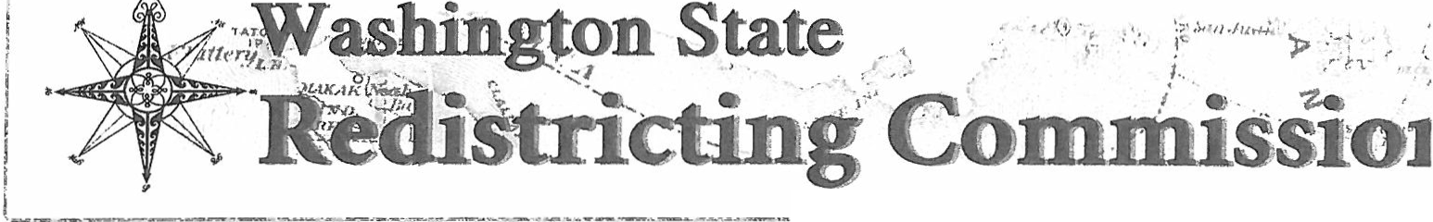
r-.·--··--·--· ......._....__,,_..,..__,. .. ·· ... ...---------...--........ --- .. --·-- .. ... ._.... ....-·-···-....---- ..

---···------· ·--------- ---·

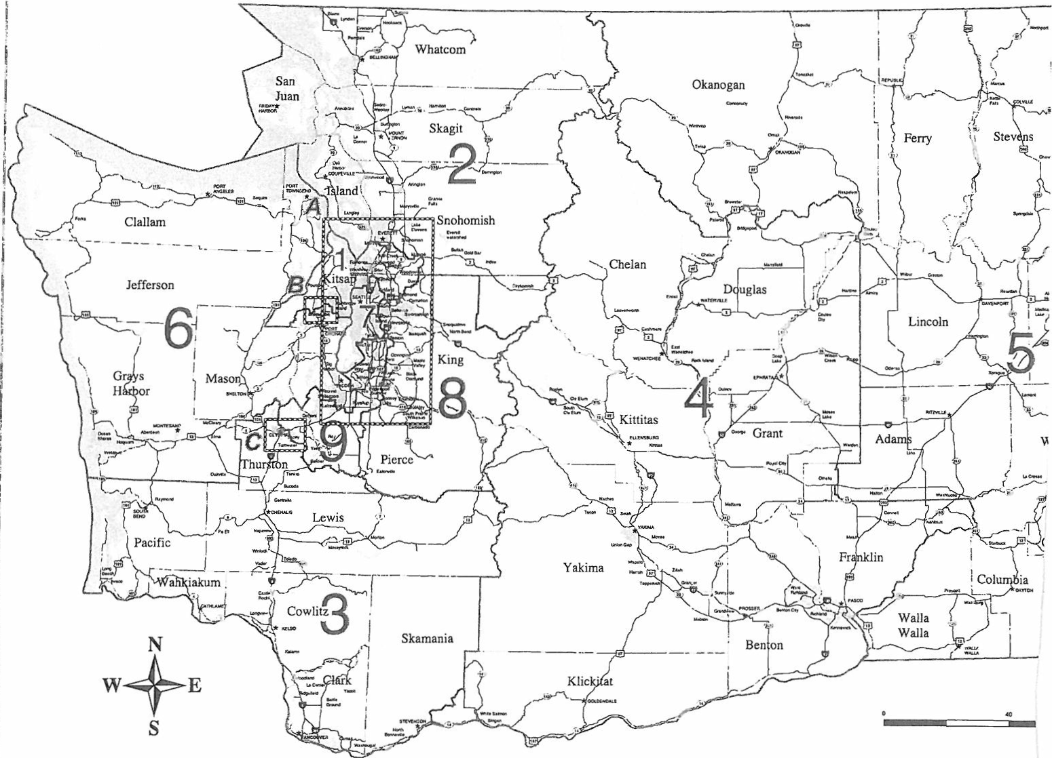

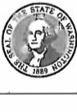
Post Office Box 40948 Olympia, WA
98504-0948
(360) 586-9000
Fax: (360) 586-9000
www.redistricting.wa.gov

--·-·"'.·--. l f'"
I I
I I
I !
f
.._ --- --- -- -... ------ ._ .. ...

--..

........_..._ '---··--·-·,........----,...
.\ J'
r; ,J -... ..:. '
Je -,....".,9,.·. ·,!_ 1'
_l
!
I
I
! --·.. . ;__ '

I'!c· -
--=-
· · ; •
Oly pia! I
m
...

=,.; --=-.:.::.:....: -----·-- ···--J
(--·--- - -ieg· d--

0Congressionalboundaries Primary highways
Local roads & streets Water
L •.• J County boundaries

Incorporated areas
0 Inset
* County seats

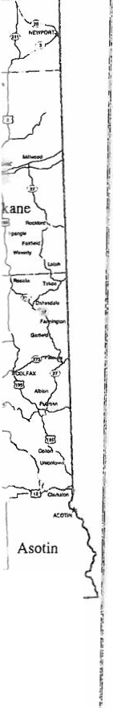
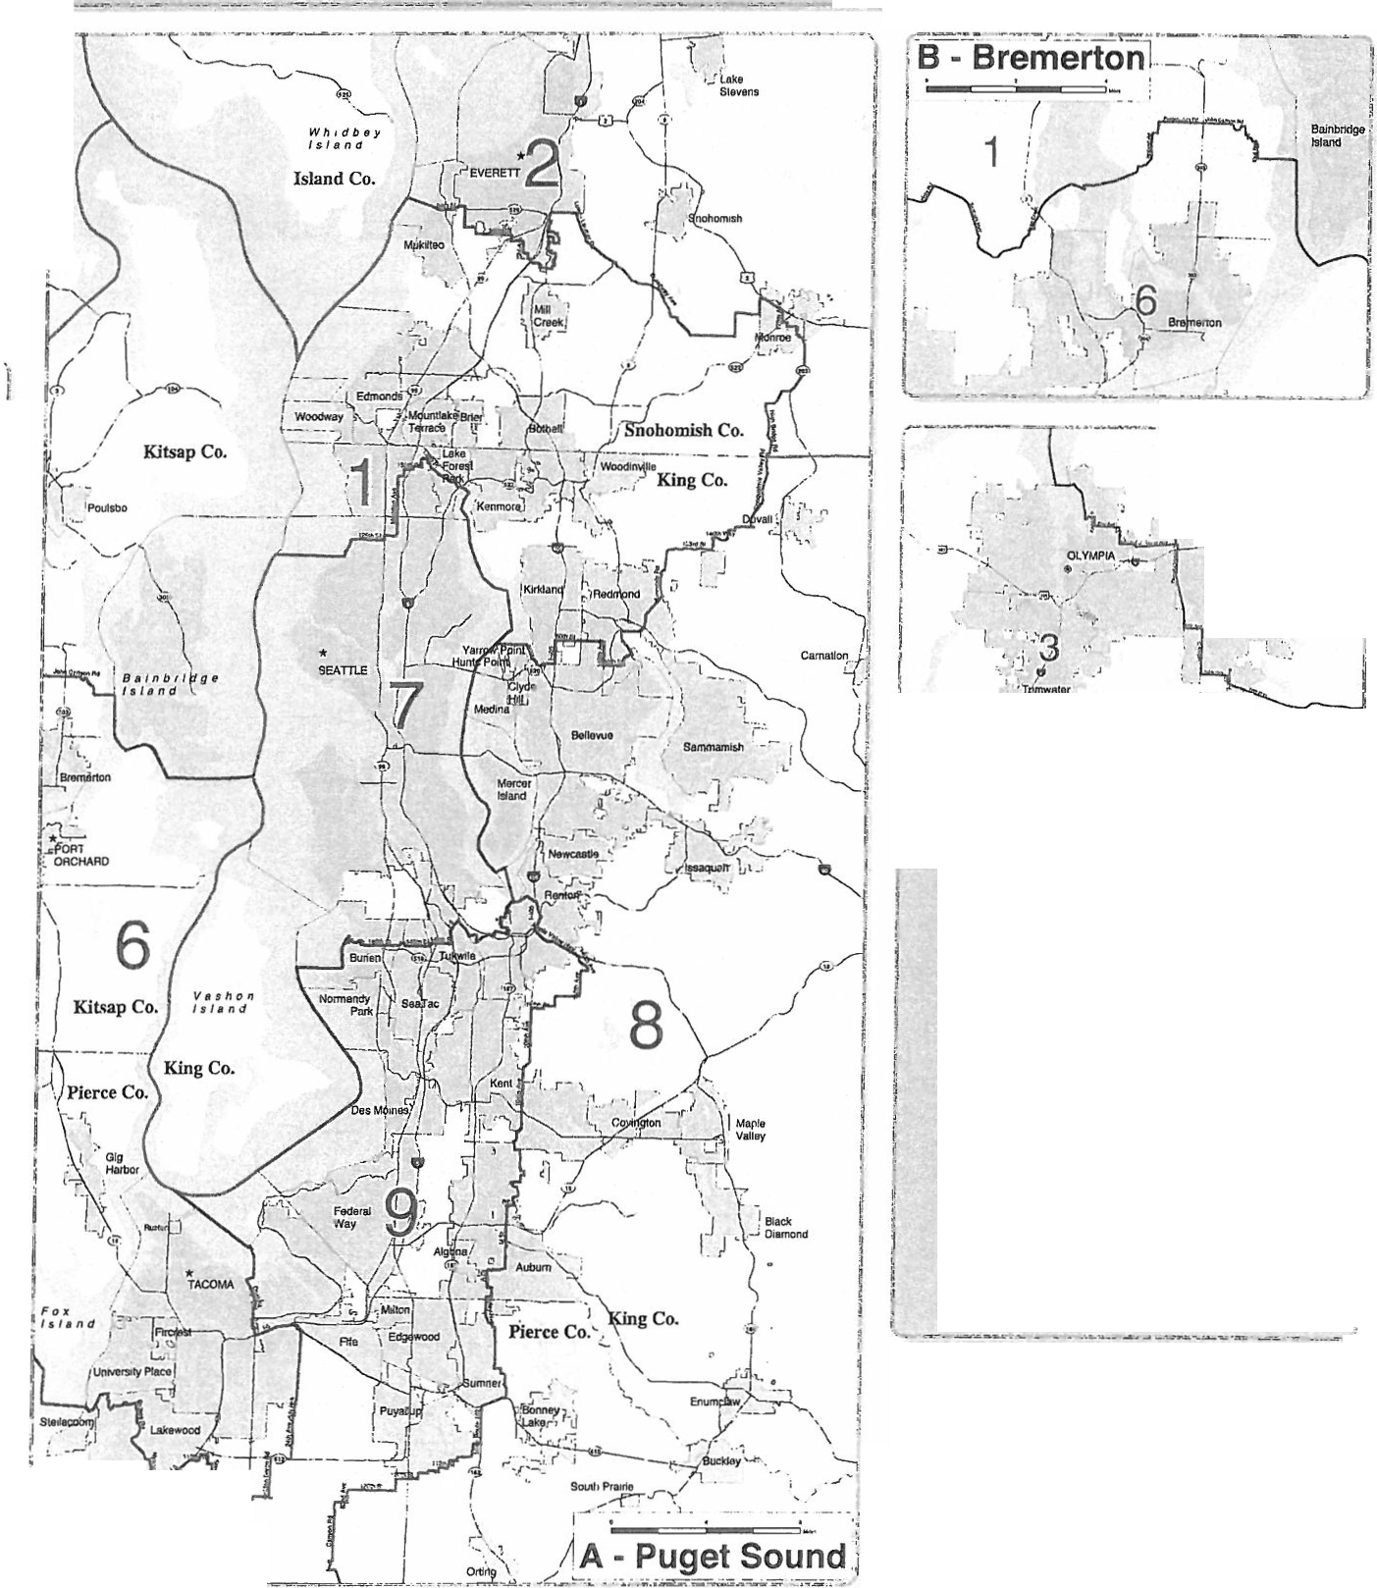

=-..

: ;- .. ,
_,........ 1
..... i
1
.•_ ,. ·--- .. ...i,".

D.lu soun:t· &d.l&trktinc Cemu, 2000 TICER/LlM FOtse. Wa lngton
file- ta. FtNAt,...CONC-2001

Congressional district boundaries as adopted by the Washington State Redistricting Commission January 1, 2002

Washington State Democratic Party Precinct Committee Officer Handbook 20

-- ---- -------- --------------- Final Legislat·,
r ­
. 1

vi.2L
I /
j,P,
l

'

l .
!-;
w
G-

I

i ..

---===---====_:.j. _ j 1-

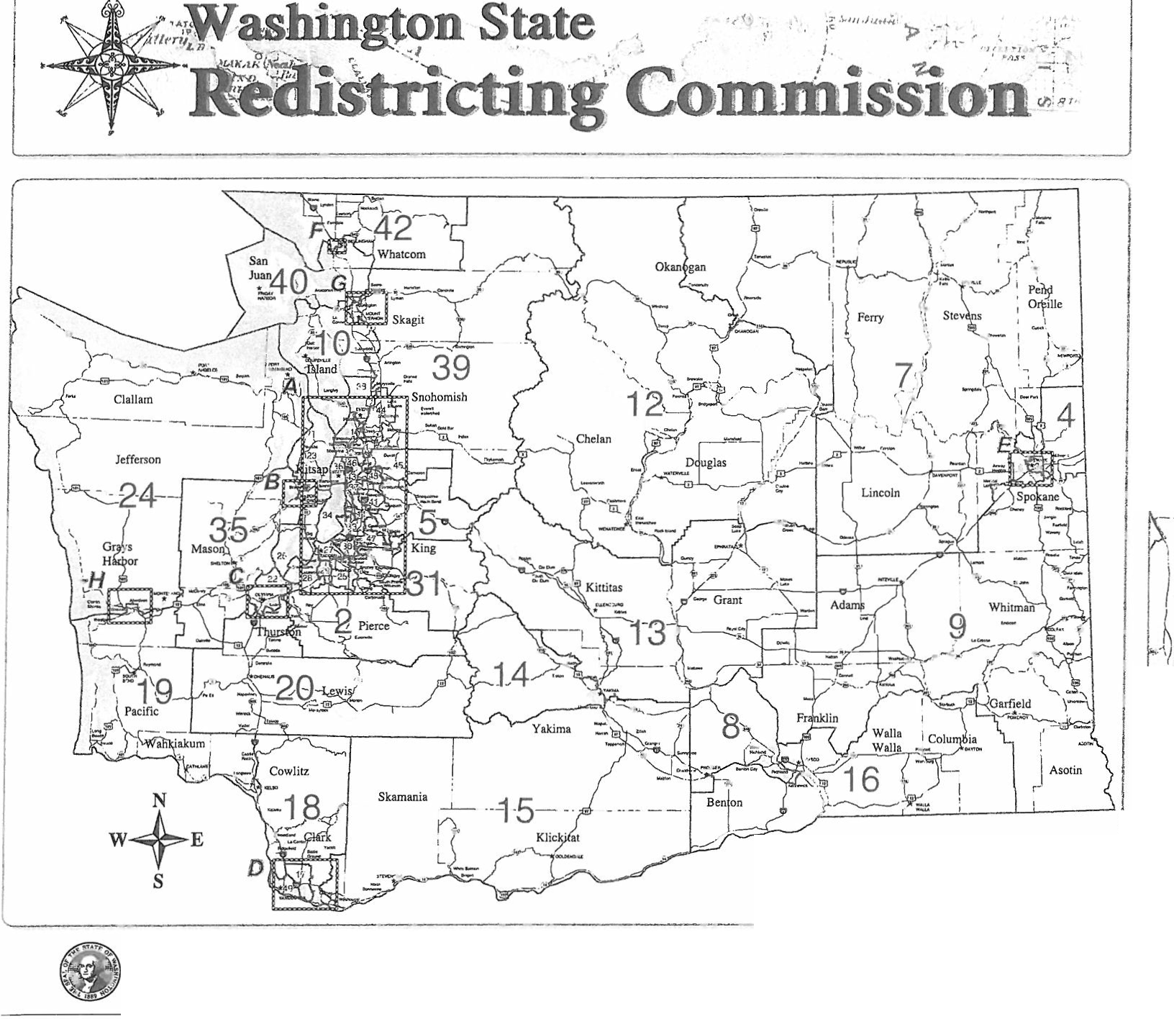
Post Office Box 40948 (360) 586-9000
Olympia, WA Fax: (360) 586-8995
98504-0948 www.redistricting. wa.gov
Legislative district boundaries as adopted
by the Washington State Redistricting Commission.
December 16, 2001

District Plan

u d-
·:
' '-,. ,

,W,h,.1ldtdta J

35'

.- :··

:-o:=::i--=:=::0- I
\ ._B I,ll_e!_to_n
23

\...

r ' · ·· · ·- i
- Bel!ingham.J

·'·
\

I
I
\
\ 39
','•nnb:' t"•

\.

·..

4

..........
*
Legend Legislative boundaries Primary highways
Local roads & streets
Waler
County boundaries
Incorporated areas
Inset
County seats

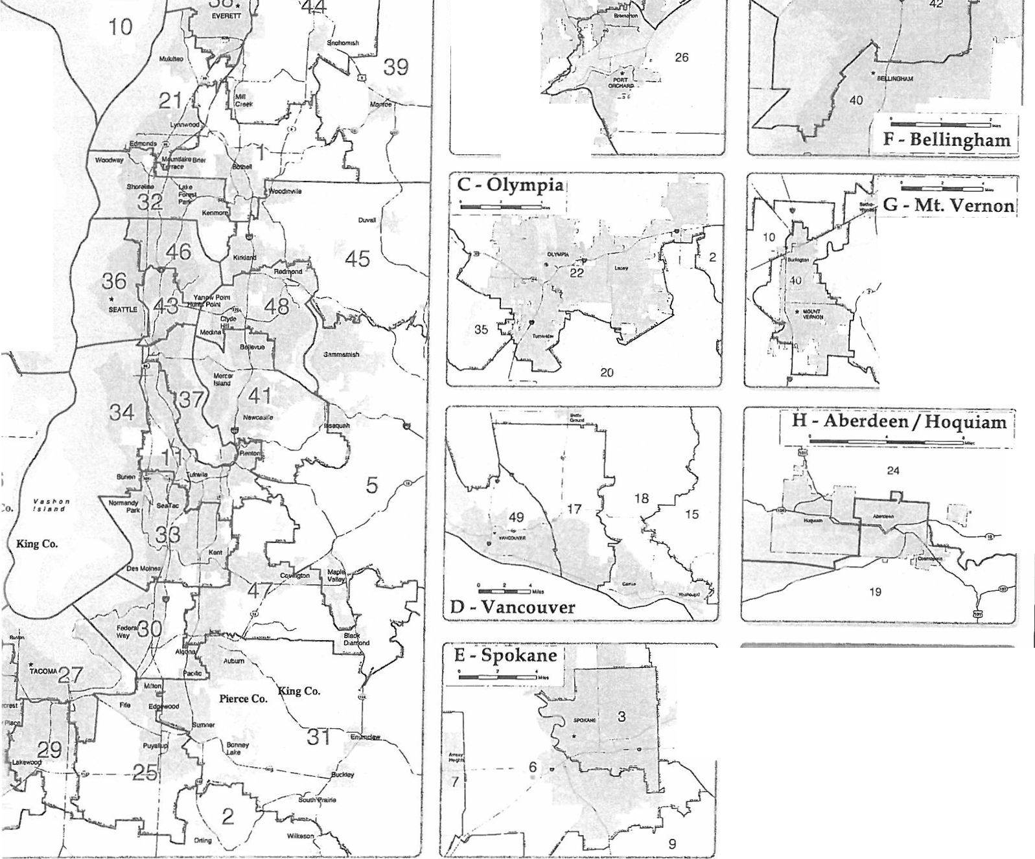
Washington State Democratic Party Precinct Committee Officer Handbook 22

Washington State Democratic Party Precinct Committee Officer Handbook

HINGTON STATE
DEMOCR.\TS

